**Candidate manually Deployment on 52**

*** Take checkout from Branch in CVS.

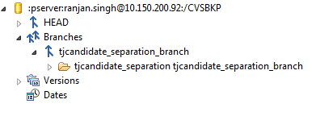

*** Right click and choose Check Out As option:

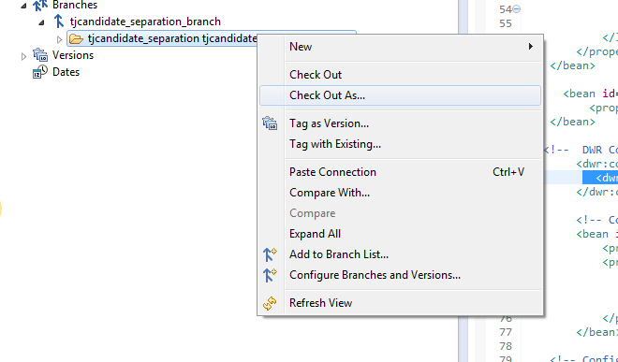

*** Give name in Project Name section and click on Finish button.

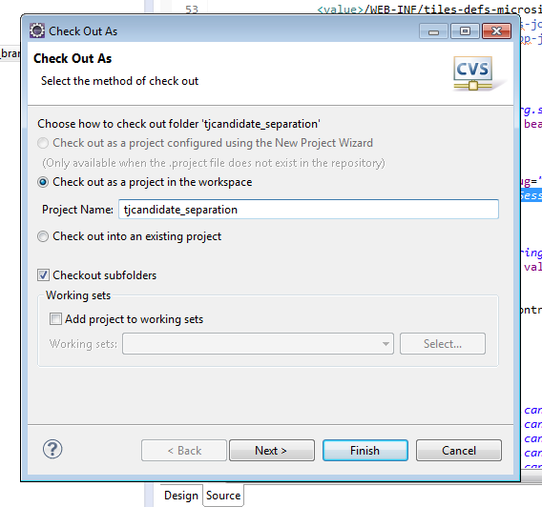

Go to java editor workspace (i.e. eclipse work-space) checkout folder path on command prompt.

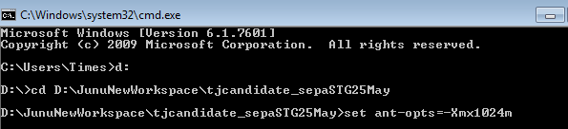

Run🡪 set ant-opts=-Xmx1024m

Run🡪 ant build-qc

Login to putty and go to -> cd /opt/tomcat/webapps/candidate/

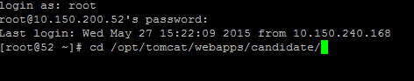

Run in putty🡪 rm – rf *

Go inside dist folder and copy the .war file to /opt/tomcat/webapps/candidate

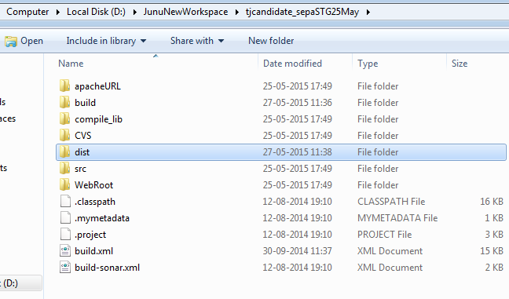

Run in putty🡪jar –xvf candidate.war

Run in putty🡪 rm candidate.war

Run in putty🡪restarttomcat

**Candidate manually Deployment on 81**

Take checkout from Head.

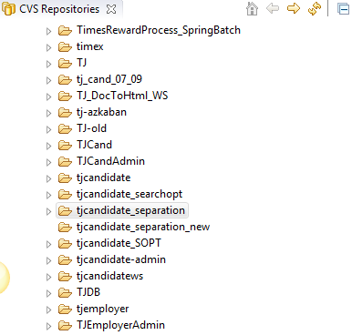

Go checkout folder path on command prompt

Run🡪 set ant-opts=-Xmx1024m

Run🡪 ant build-stg

Go to location in putty -> /opt/tomcat/webapps/candidate/

Run in putty🡪 sudo rm – rf *

Go to dist folder and copy the .war file to /opt/tomcat/webapps/candidate

Run in putty🡪 jar –xvf candidate.war

Run in putty🡪 rm candidate.war

Run🡪 ps –ef|grep tomcat

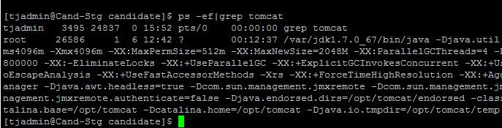

If JDK found then kill the process (for above jdk process id: 26586)

Run🡪 sudo Kill -9 jdk process id

Run🡪 sudo /opt/tomcat/bin/startup.sh

**How to Run Script Minify**

Generate ajaxController.js file for Candidate (QC/Staging)

QC: <http://candqc.timesjobs.com/candidate/dwr/interface/ajaxController.js>

Stg url: <http://candstaging.timesjobs.com/candidate/dwr/interface/ajaxController.js>

Open the url in browser and copy the entire content and save it to checkout tag in eclipse (Open ajaxController.js in eclipse and paste). Now go to checkout folder path on command prompt and Run below command.

ant scriptMinify

Note: Before running scriptMinify, make sure to change properties of the script folder in checkout tag to Read only mode. And above process to be run after build is running after deployment.

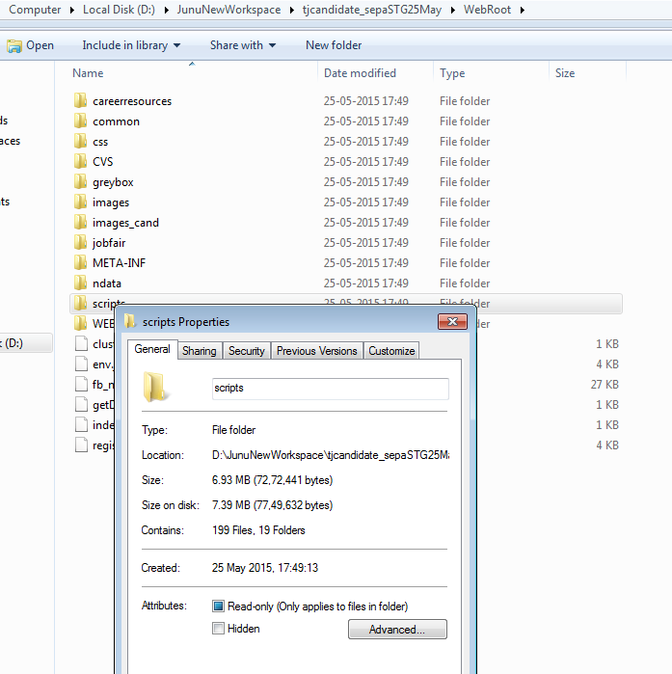

Uncheck the Read only option.

**Candidate Live deployment:**

The Process for live deployment is same as stg deployment, the only difference is we need to create the war file using ant command in command prompt.

No need to run again scriptMinify if not advised.

**NAF Deploy Server 54:**

cd /home/script

./naf_qc_build.sh

cd /home/script/naf/dist

ls

rm -rf /opt/tomcat/webapps/naf/*

cp -rf naf.war /opt/tomcat/webapps/naf/

cd /opt/tomcat/webapps/naf/

jar -xvf naf.war

rm naf.war

Restart server